Japanese scientists grow functional human liver from stem cells

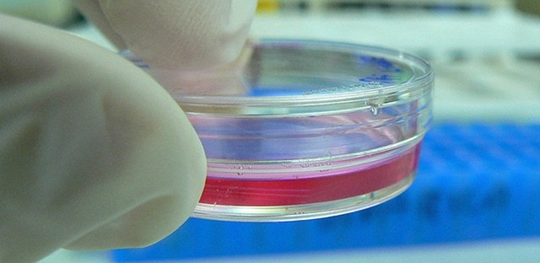
A team from the Yokohama City University in Japan have for the first time grown a functional human liver using human induced pluripotent stem cells (iPSCs). In their paper published in Nature, the researchers note that no studies have previously succeeded in generating a 3-dimensional vascular organ such as liver from iPSCs. However, lead researcher Prof Takanori Takebe was reportedly “gobsmacked” to find that when they mixed hepatic endoderm cells, mesenchymal stem cells and endothelial cells, liver buds formed spontaneously.
After the researchers transplanted the human liver buds into sites in the cranium and abdomen of mice, the tiny 4mm buds matured and, incredibly, connected to the blood vessels of the mouse host. The iPSC-derived liver tissue performed normal liver functions such as protein production and drug metabolism, and transplantation also increased the life span of mice with liver failure.
The research is of course exciting, as it provides proof of concept for a potential solution to the scarcity of human livers for transplant. However, it could be another 10 years before such ‘grow-your-own’ laboratory livers could be used to treat patients. The functional livers grown were rudimentary, and there’s also need for longer term follow-up in the animal models to see if the transplanted tissue forms tumours or simply dies out.
Whether the approach could offer a viable alternative to human organ transplantation still remains to be seen – but even if it doesn’t then the iPSC-derived liver tissue could still be useful for testing the liver side-effects of drugs in development.

